PRESS RELEASE

- SUMMER 2012 UK TOUR -

IN THIS PRESS RELEASE:
- News on ‘THE JO BURT EXPERIENCE SUMMER 2012 UK TOUR’
- Dates and tickets
- Profiles of confirmed supporting bands

****************************************************************************

Jo Burt knows a thing or two about delivering kick-ass music. Following an illustrious career playing bass with bands such as Sector 27, Black Sabbath, Virginia Wolf, Bob Geldof and the late Freddie Mercury, Jo assembled a formidable band to focus on what is his most personal music yet.

The line-up of The Jo Burt Experience also includes drummer Andy Treacey (Faithless, Dido, Moby, Robbie Williams, Groove Armada, Tom Robinson) and guitarist Dzal Martin (The Equals, Terry Reid, Tom Robinson, Van Morrison, Meatloaf). Prepare yourself for some imaginative melodic rock & acoustic ballads in the British tradition and a great live experience.

The Jo Burt Experience spent the last few years gigging within the UK and occasionally in mainland Europe, all the while finetuning their craft. This summer the band ups the ante on the gigging circuit with a handful of UK dates. Then, without waiting to catch their breath, in July the band then crosses the pond over to Canada for another set of live dates. This is going to be a huge year for the band!

For more information on The Jo Burt Experience, including biography, discography and music samples, please go to www.joburt.co.uk .

----------------------------------------------------------------------------------------------------

(Dates + venues + supporting bands at each date)

*(With Star Scream + Captain Horizon)
**(support to be confirmed)

18th May - 'The Fighting Cocks' (Kingston)*
23rd May - 'Monto's Water Rats' (London)**
31st May 'The Portland Arms' (Cambridge)*
-----------------------------------------------------------------
9th June - 'Thomas Tripp' (Dorset)**
13th June - 'Bull's Head' (London)**
16th June 'Tabernacle Junction' (Yeovil)**

(More dates to be announced)

Tickets from:
www.seetickets.com or www.ticketweb.com

For more information please go to:
www.joburt.co.uk or www.facebook.com/events/376301825722893/ .

----------------------------------------------------------------------------------------------------

STAR SCREAM
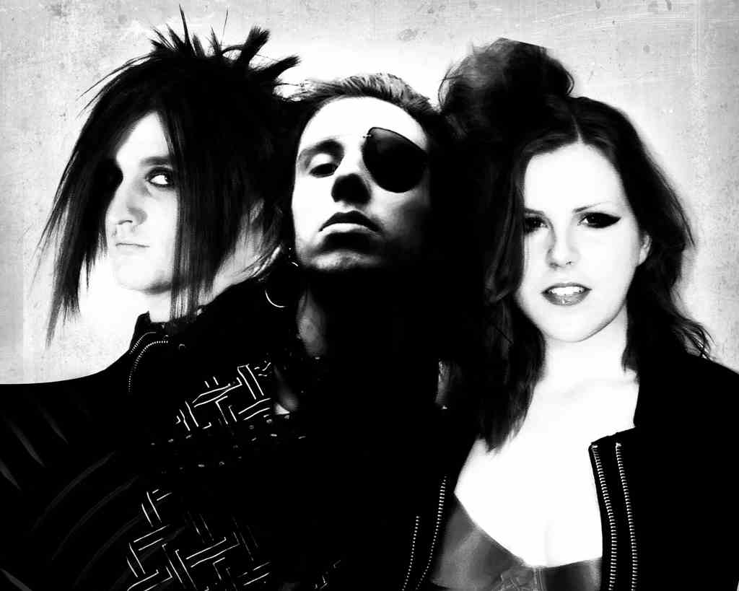

It's hard enough describing a band at the best of times, but Star Scream do an excellent job of making the task doubly hard. If you try to picture the bastard offspring of Marilyn Manson starring in Rob Zombie epic, directed by Tim Burton and scored with a combination of Little Shop of Horrors, Muse and the Manic Street Preachers, you still won't be half way towards understanding what Star Scream will do to your ears. But you should have an idea of just how intense, exciting and unrelentingly heroic it's going to be.

The band have toured with glam legends such as Queen Adreena & Rachel Stamp. They were hand selected by Casey Chaos to accompany musical giants Amen, not once, but twice and in 2006 bested over 700 competitors to play the 10,000 capacity TMF festival. Meanwhile, backed by glowing press reviews, the band's début EP, “Liquid & Pain” and Single ‘Bedroom Eyes’ both sold out.

Star Scream's first album, “Sexploitation”, is, after years of anticipation, finally ready for release, thanks to the hard work of the band and input from none other than Jon Astley, who's touch has graced the work of bands from Ash, to Eric Clapton and Tears for Fears, to The Who.

It goes without saying that one hell of a lot of musical ability has been compressed into this audio singularity. You've never heard anything like it before, and you'll damn sure want to hear more afterwards.

Adam Lightspeed - All Music & Lyrics, Vocals, Guitar, Piano
Aoife - Bass
Dom Jenova - Drums

www.starscream.co.uk

---------------------------------------------------------------------------------------------------------------

CAPTAIN HORIZON

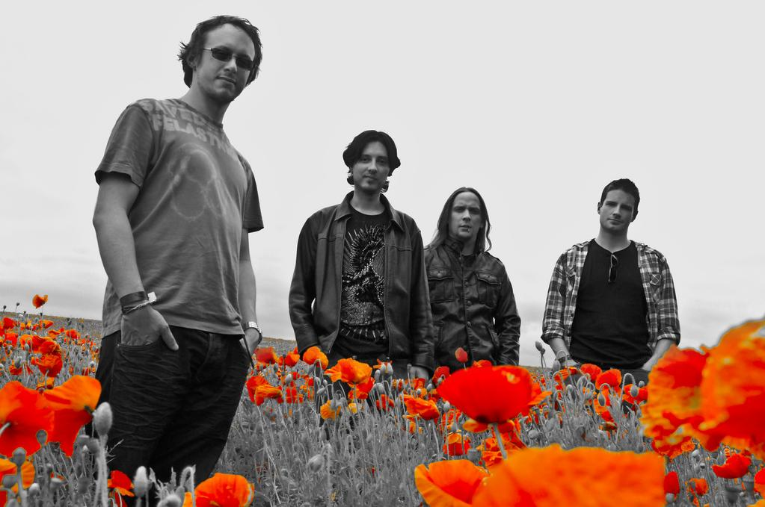

Captain Horizon are a powerful 4 piece alt-rock band from the Midlands. With an expansive set of original songs and a wide range of influences, the band deliver their music live in an explosive set bursting with passion and energy. This is a band that believes in what they’re doing.

The band was born in the summer of 2008 when guitarist Josh and bass player Alex started writing songs that brought together the high energy and intricacy of music from bands like Incubus, Radiohead, Tool and Porcupine Tree, and the classic swagger of stadium bands like AC/DC, Pearl Jam, Pink Floyd and U2. Mez joined shortly after and set to work bringing his unique brand of precise and original drumming to the music. Whitty was the last piece of the puzzle, using his stage presence and voice to inject an unstoppable self belief and a strong melodic sense.

Gigging solidly through 2009, the band have honed their live skills and continue to write songs ranging from the hard hitting “Jack Herer” and “Poker”, through the brooding “EL Nibre” and “What’s Going on”, to the emotive “Tears From the Eye”. They’re not afraid to explore new kinds of music, with “Turn Away” and new song “Stop” perhaps best showing their ability to blend arena rock, Punk and Indie energy, and expansive sonics. With festival dates, gigs at the O2 academy and a strong 4 track EP under their belt, the band are poised for and aspiring toward great things.

Steven “Whitty” Whittington – lead vocals
Josh Watson - guitars
James “Mez” Merrix - drums
Alex Thomson - bass guitar

www.captainhorizon.co.uk

